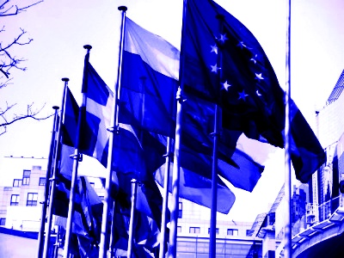
Master’s Degree in
International Relations and European Studies (RISE)

RISE Guest Seminars RIFLETTORI SUL MONDO

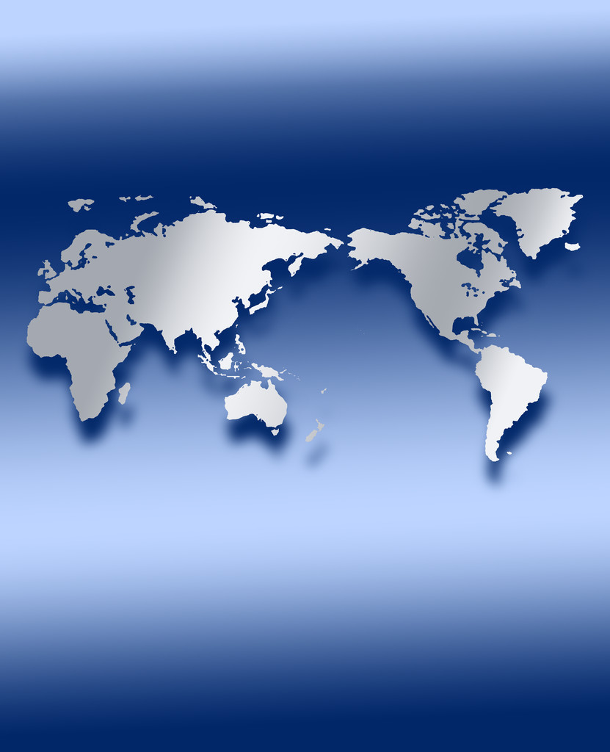

Michel Catala
Université de Nantes
(Centre de recherche en histoire internationale et atlantique)

La France, l’Espagne et l’indépendance du Maroc.
Aux origines de la question du Sahara Occidental

Friday April 15th, 10,15 a.m.
Polo delle Scienze Sociali, Building D5, Room 1.10

All those interested are welcome to attend

