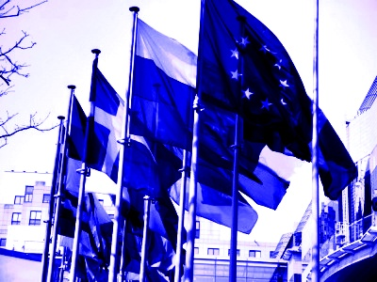
Master’s Degree in
International Relations and European Studies (RISE)

RISE Guest Seminars: RIFLETTORI SUL MONDO


Prof. Stefano Bartolini
(Peter Mair Chair in Comparative Politics
-
European University Institute)

Mass politics in the EU ? Electoral representation between national and European Arenas

12:00- 14:00

15 April 2014, Polo delle Scienze Sociali
Building D6, Room 106

All those interested are welcome to attend

